Introduction to deep learning

# What is a neural network?

ReLU – Rectified Linear Unit

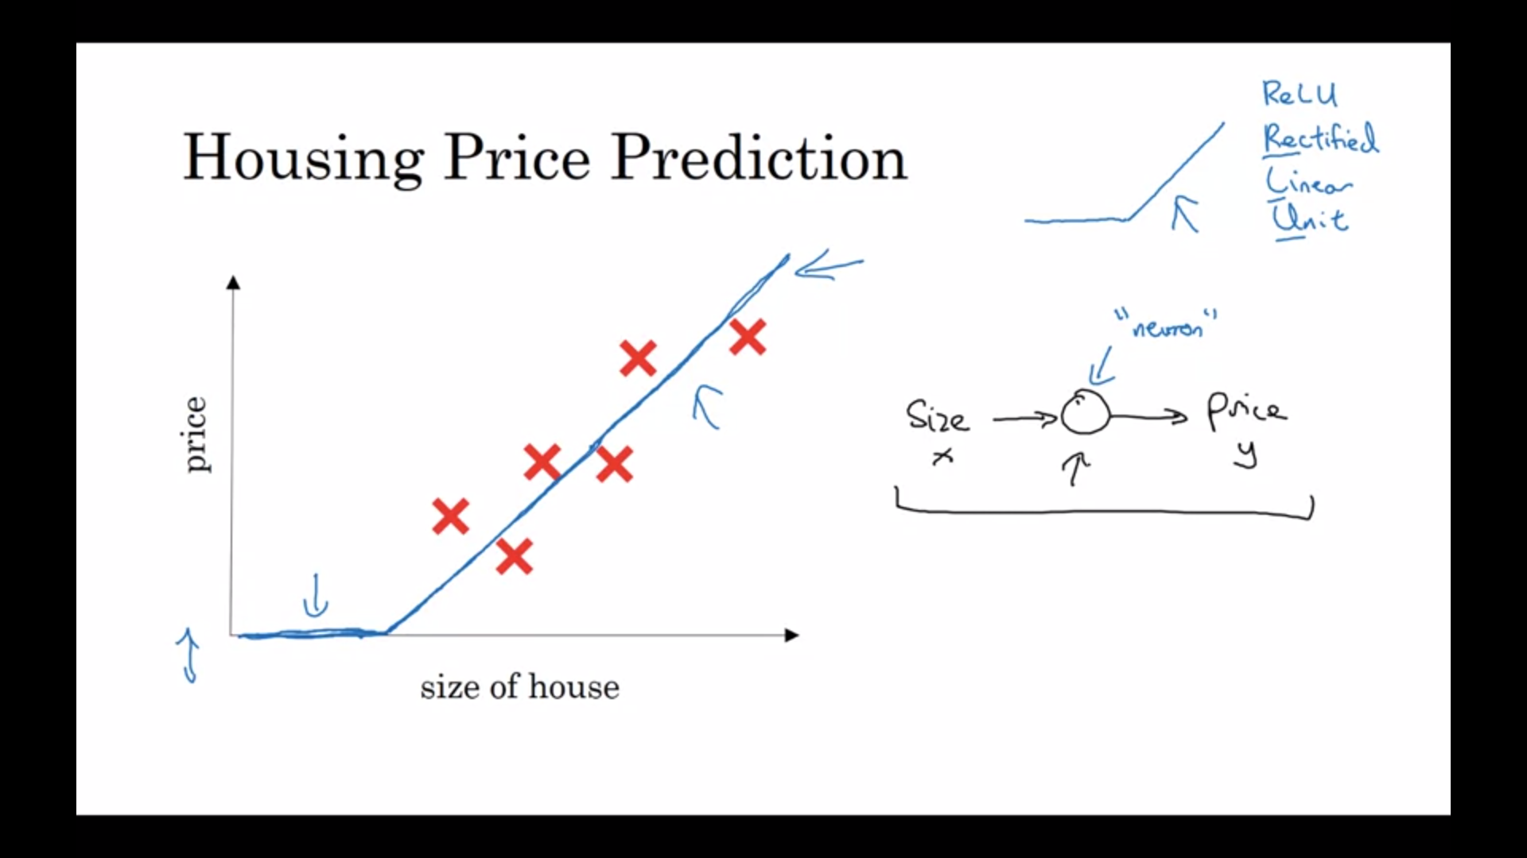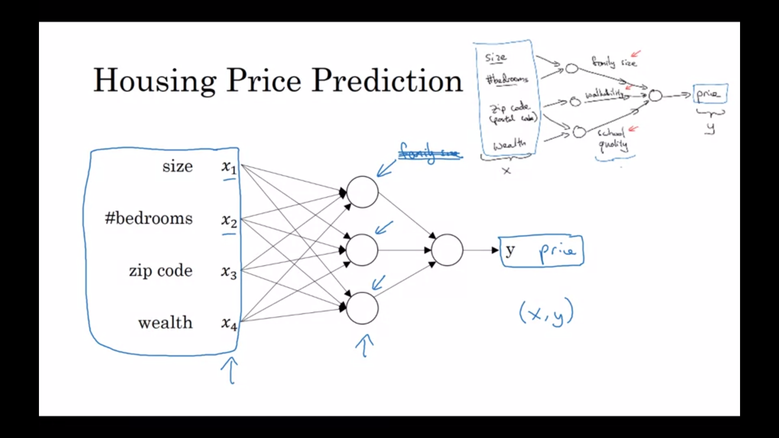

# Supervised learning with neural networks

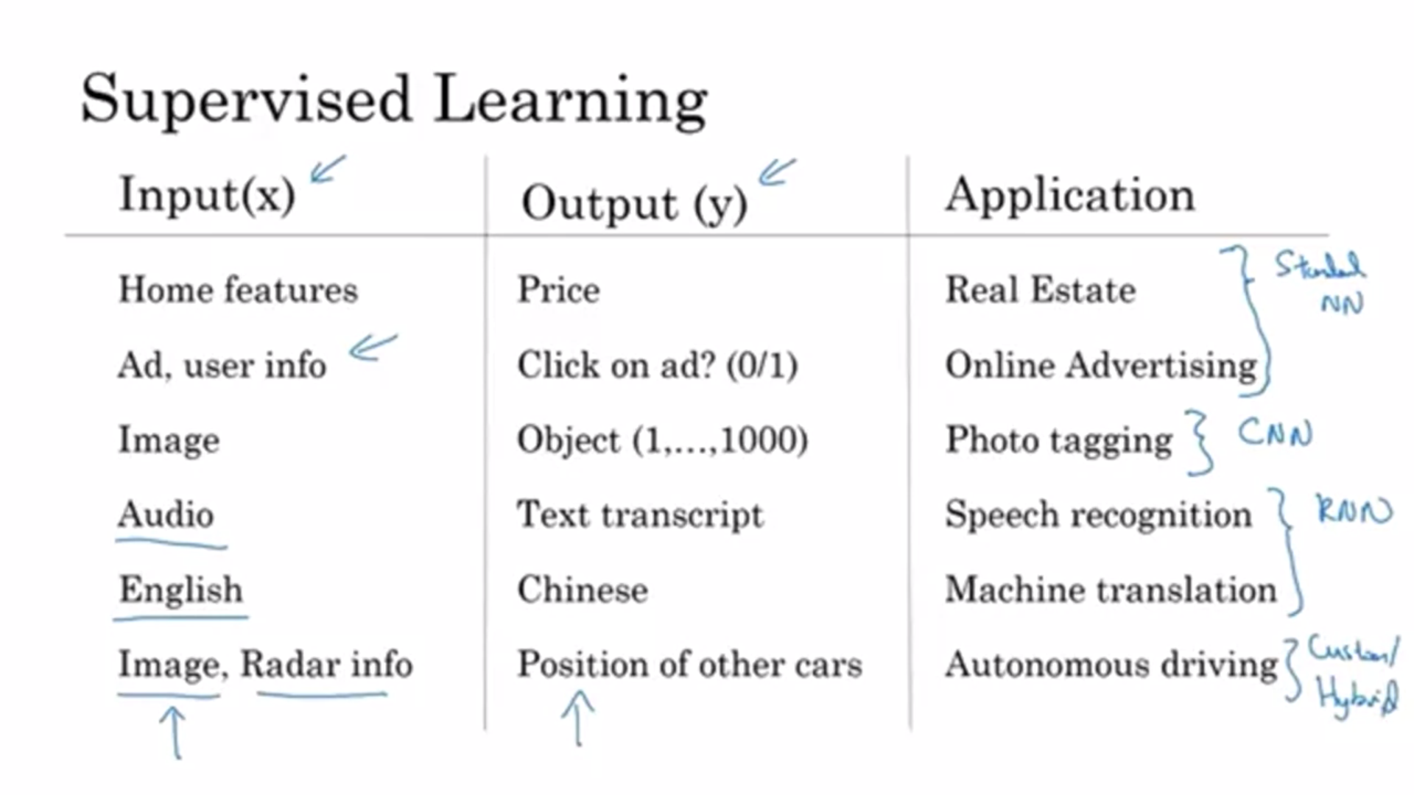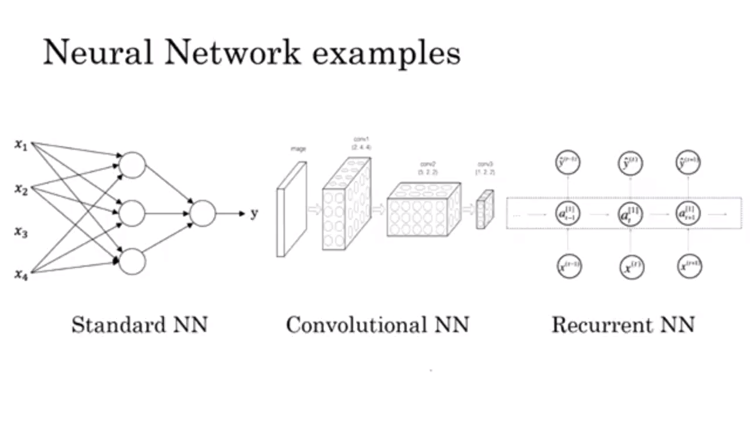

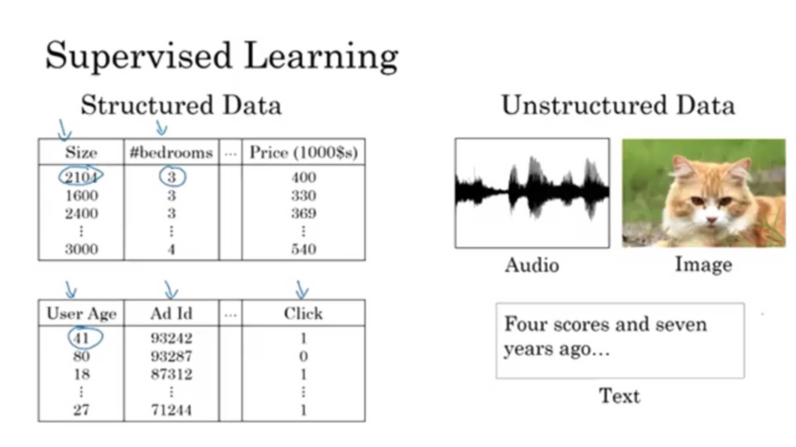

# Why is deep learning taking off?

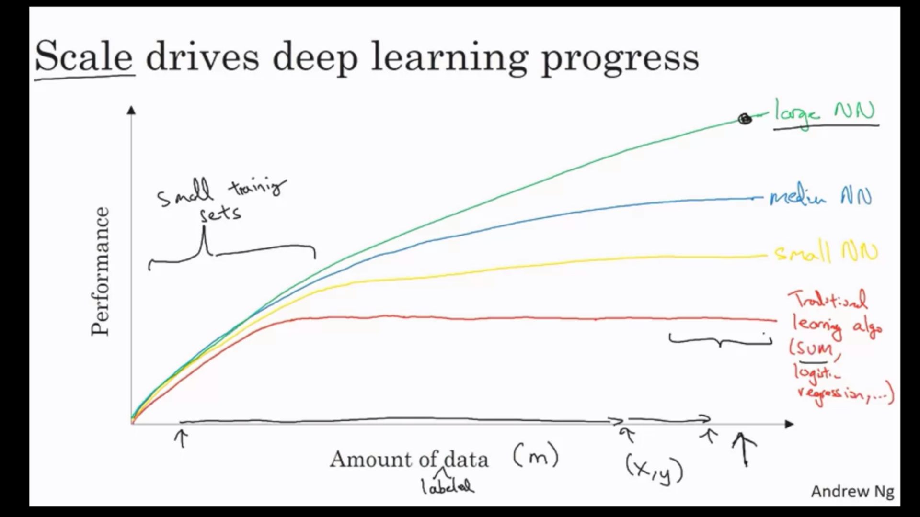

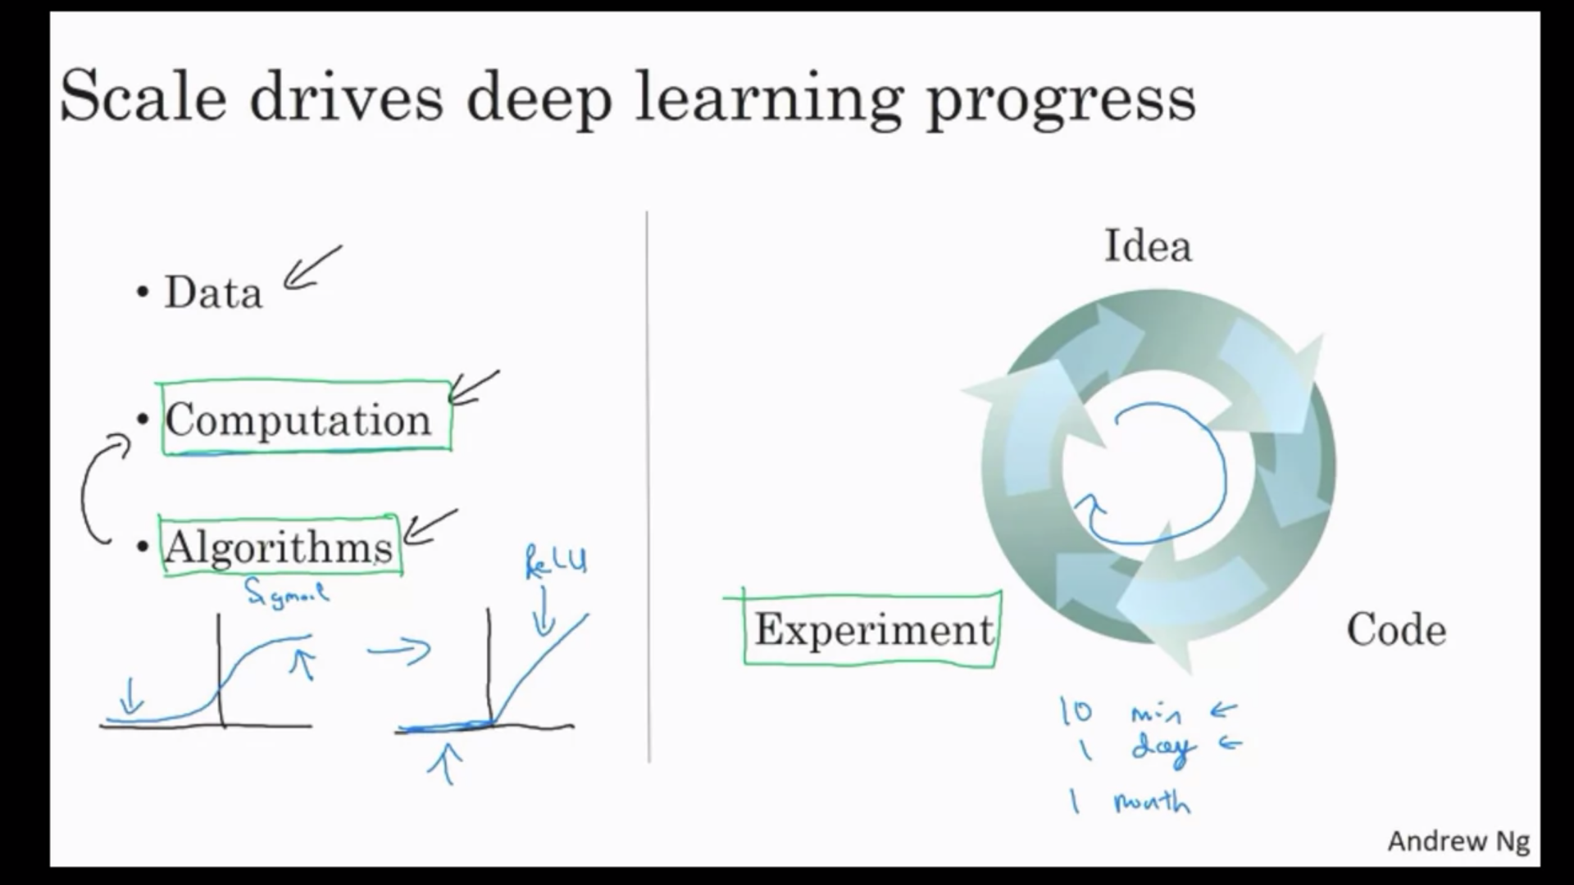

Recently, there has been innovations in algorithms used for NN, for example – the shift from sigmoid to ReLU functions helps gradient descent to run faster. Since at the ends of sigmoid function where graph flattens out and gradient is zero, it was observed that gradient descent was learning very slowly.